## **“CADENAS is a key element in making IMI Precision Engineering an online world class experience”**

IMI Precision Engineering is seeing a huge increase in customer satisfaction all thanks to the first ever integration of eCATALOGsolutions into an eShop

**Augsburg, Germany, 16th of January 2017.** For IMI Precision Engineering customer satisfaction is key and providing product information in a simple and easy to use product configurator was the best solution for their pneumatic actuator ranges. An eCATALOGsolutions Electronic Product Catalog was seamlessly integrated into the existing website and eShop maintaining the full IMI Precision Engineering branding. “CADENAS was the obvious choice due to the ease with which we could embed configuration technology and CAD downloads into our existing website,” explains Jez Ashton IMI Precision Engineering Global Online Marketing Manager. IMI Precision Engineering believe that the eCATALOGsolutions forms a key part of their online marketing strategy for their products which is powered by CADENAS.

**Seamlessly Embedded Portal into the Existing eShop**

Actuators and grippers are the first two examples of configurable products with many more to follow which will be offered by IMI Precision Engineering a global manufacturing company with locations in over 75 countries. The CADENAS solution supports multiple languages ensuring the offering is truly global, as well as providing over 100 native CAD formats online within the eShop. “An Electronic Product Catalog is something that CADENAS has been providing for over 20 years. For IMI Precision Engineering we wanted to take it to the next step and offer an embedded portal that communicates with the customers’ existing eShop and CRM system. This is the first, but certainly not the last time CADENAS has done this type of link between a companies’ existing set up and a new Electronic Product Catalog,” explains Jürgen Heimbach, CEO of CADENAS GmbH.

The client can select the product they want, configure it to the specific dimension required with the help of pictograms, and then check the availability and price before buying it directly online. “Our customers can configure product, obtain a price and availability and order online instantly. All the information needed is available in real time and the user has it all presented on a single page of the website. Configuration and CAD functionality provided by CADENAS is a key enabler as we strive to provide a world-class online solution,” further explains Jez Ashton. The 3D CAD download portal is seamlessly embedded within the eShop ensuring an individual tailored offering within the existing IMI Precision Engineering branding that clients recognize.

**An Increase in Sales Leads**

A specific part number is assigned to each customer configured product that has been downloaded. This is then stored within the IMI Precision Engineering CRM system along with the customer details enabling the sales nurturing process to begin. Nurturing involves providing additional and relevant product information that has been tailored to the specific product downloads that have been made. This ensures higher customer satisfaction and customer conversion rates which is a win-win situation for client and provider alike. IMI Precision Engineering predicts that this link between the systems will help to drive an increase in sales. “It took no time at all before both teams of CADENAS and IMI Precision Engineering to build an efficient working relationship. It was a very easy transition,” tells Jez Ashton of IMI Precision Engineering.

**Just the Start for IMI and CADENAS’ Relationship**

“Creating an Electronic Product Catalog that is seamlessly integrated within the existing IMI eShop and CRM system was highly recommended by CADENAS. We believe in becoming a trusted partner and advisor with IMI Precision Engineering in order to help deliver a “Best In Class” online go to market offering for their complete product range,” announces Colin Johnson, Director of CADENAS UK. IMI Precision Engineering plan to extend not only the offering to their entire product range but also across locations around the world. This will ensure the solution is tailored by country location helping to further provide a specifically customized end user experience.

**Test it For Yourself**

To see more of IMI Norgren’s online and configurable 3D CAD manufactured products follow the link to their eShop: [store.norgren.com](http://store.norgren.com)

And to learn more about making your own Electronic Product Catalog powered by CADENAS see here: <www.cadenas.de/en>

**Press Images:**

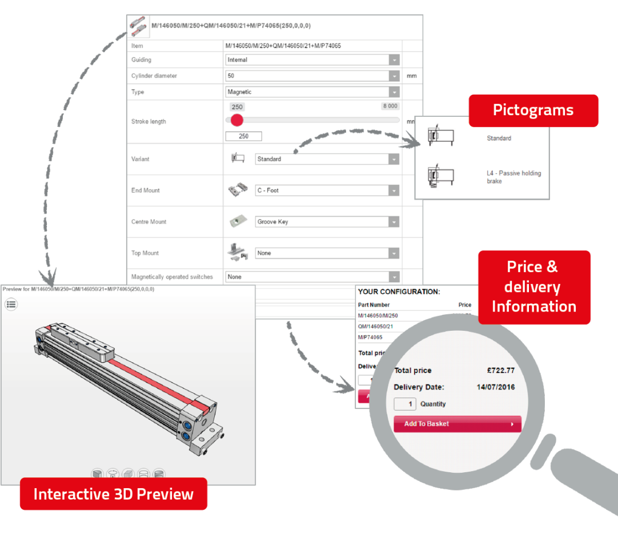

**Caption 1:** Features of the product configurator by IMI: pictocrams, price & delivery information, interactive 3D preview.

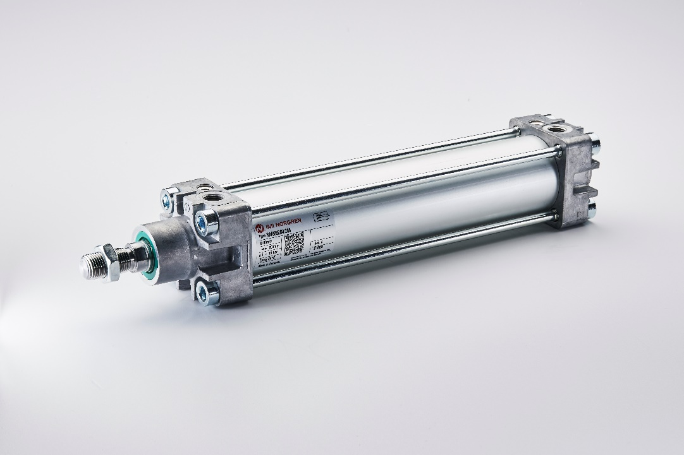

**Caption 2:** Pneumatic actuator by IMI Precision Engineering.

This press release and accompanying images are available for download from our website: [www.cadenas.de/press/press-releases](http://www.cadenas.de/press/press-releases)

**About CADENAS**

CADENAS is a leading software developer in the areas of Strategic Parts Management and parts reduction (PARTsolutions), as well as Electronic Product Catalogs (eCATALOGsolutions). With its customized software solutions, the company acts as a link between the component manufacturers with their products and the purchasers.

With its 300 employees at 17 international subsidiaries, the name CADENAS (Hispanic: process chains) has been standing for success, creativity, support and process optimization since 1992.

For further information, please visit: www.cadenas.de/en